# http://maps.maphill.com/zimbabwe/matabeleland-south/umzingwane/maps/physical-map/physical-map-of-umzingwane.jpg

## Summary of main characteristics

DESCRIPTION

* Umzingwane is located in the North eastern part of Matabeleland South province, and shares boundaries with Gwanda to the south, Insiza to the East, Umguza to the North and Bulawayo city to the west.
* Has a total population of 71680 according to the 2022 census , 17000 households with an average size of 4 and settled on a land area of 7 220sq.km but total arable land is 33 000 ha.
* The district is the mostly densely populated in the province with 50persons per square kilometer in the communal lands.
* Has a total of 20 wards, which can be separated into the North, Central, East and West regions.
* The district falls under AEZ III, IV and V. With regions III and IV typically receiving 450 to 650mm of rainfall. The latter is subject to periodic seasonal drought spells receiving no more than 400mm of annual rainfall.

**North** made up of wards 1 and 2 which are communal old resettlements

* Found in AEZ[1] V
* Closer to Bulawayo but has limited land for agricultural activities, on average a households owns less than 5acres arable land.
* Low rainfall, usually less than an average 350mm annually, uncertain for crop production purposes
* Crop production also limited because of shortage of draft power and seed and rocky terrain. Although own production is failing, the region is well served by infrastructure as tapped water, electricity and good transport networks which however, is utilized by less than 50% of the communities due to low economic base for most communities who depend on rain fed subsistence farming.
* Young able bodied man (16-45years) actively involved in gold panning which also in a way impact negatively on both the environment and water bodies.

**Central** consists of wards 3, 4, 5, 6, 7, 8, 11, 12, 15, 16,17and 182

* Wards 15, 17, and 18 are small scale farms with a AEZ III type of climate and wards 19 and 20 are new resettlement area, whilst the rest are communal under AEZ V
* Communal area characterized by severe gully erosion as wards 3 and 4 and in some areas as ward 10 there is a high prevalence of tree cutting. These are used for curving purposes. Stream bank and vlei cultivation also common in ward 8and 9 where the community depends on market gardening.
* Ward 16 however is the Esigodini business centre itself with very little agricultural activities going on, most are confined to homestead gardens in Habane Township. Served by infrastructure as post office, shops, DA office,social welfare offices and generally all functional district administrative and health offices in Umzingwane.
* Perennial droughts have crippled Wards 12, 14, 15,17, 18 ,19, 20 of being and part of ward 5 are the breadbaskets of the district.
* In good years farmers have two crop seasons, the first crop is planted early October, and by beginning of February will be planting their second maize crop
* Served by the only partly functional irrigation scheme (ward 5-Mzinyathini irrigation scheme) in the district, with an average of 0.4ha per plot holder. Has 81 plot holders.

**East** made up of ward 13 which is an old resettlement and 14, 19 and 20 which are new resettlement area.

* Area in AEZ IV and in terms of crop production and agricultural production part of the district breadbasket, after the small-scale commercial farms.
* Ward 14 constitutes the bulk of the total district area, covers almost half of the total district area.
* Maize grown as a major cash crop and food crop

**West** consists of wards 9, 10 and 11

* Have a communal settlement pattern
* Fields in
* Matopo Communal Lands this area have very little space for dry land cropping. Major activity is gardening and sale of fruit. Mangoes, nartjies, guavas and oranges do well in this part of the district.

The district has the following irrigation schemes and nutrition gardens

1.Mzinyathi Irrigation – Ward 5

2. Kumbudzi Irrigation Scheme Ward 12

3. Portbury Ward 20

Duncal Irrigation scheme in ward 2 is currently not functional and needs refurbishment. In addition there are

the following I hector gardens are also available – Qhama, Madiliwola, Nswazi and Zimbili.

**.Natural resource endowments:**

1. District endowed with a lot of minerals, scenic features that include water falls and gold deposits, which have not been fully utilized, hence the illegal gold panning in wards 1, 2, 3, 14 and 18.
2. Major rivers that cut across the district are Mzingwane and Mtshabezi while Thuli river is a on the western boarder of the district with Matobo District. All this three are tributaries to Limpopo river

**Tourism**

The district has various tourist attractions. These include unusual caves with rock art depicting the historic occupancy of the district and the then survival skills. In addition, South West Part of the district, Matopo Communial lands is waterfalls at Lumene , Diana (Embizeni) Pools, and Matshatsha Falls . Matopo rare balancing rocks, and rock formation including the orbicular granaite

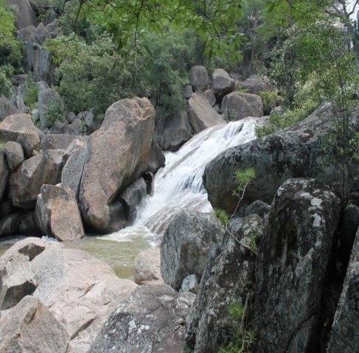

*LUMENE FALL*

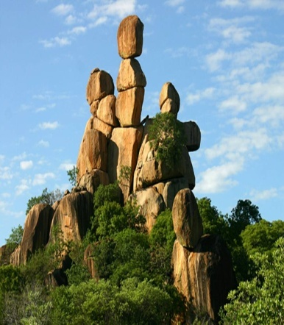

***Umzingwane distinctive rocks within the Matopo World Heritage Buffer Zone***

There is a variety of bird species – estimated to be two hundred and thirty bird species including the black eagle found in at Mtshabezi valley mainly around the Mtshabezi dam

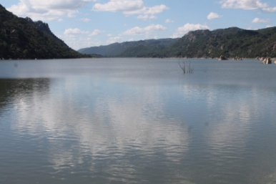 MTSHABEZI DAM

The culture of the district is still intact. Local communities still respect their shrines and sacred places. Umzingwane communities still live to demonstrate their strong religious beliefs based on their culture. The Matobo Communal lands composed of wards 4, 8,9,10,11 and 12 fall within the Matobo World Heritage Site buffer zone that was nominated basing on the cultural significancy of the communities around the site.

Diana’s Pools (embizeni)

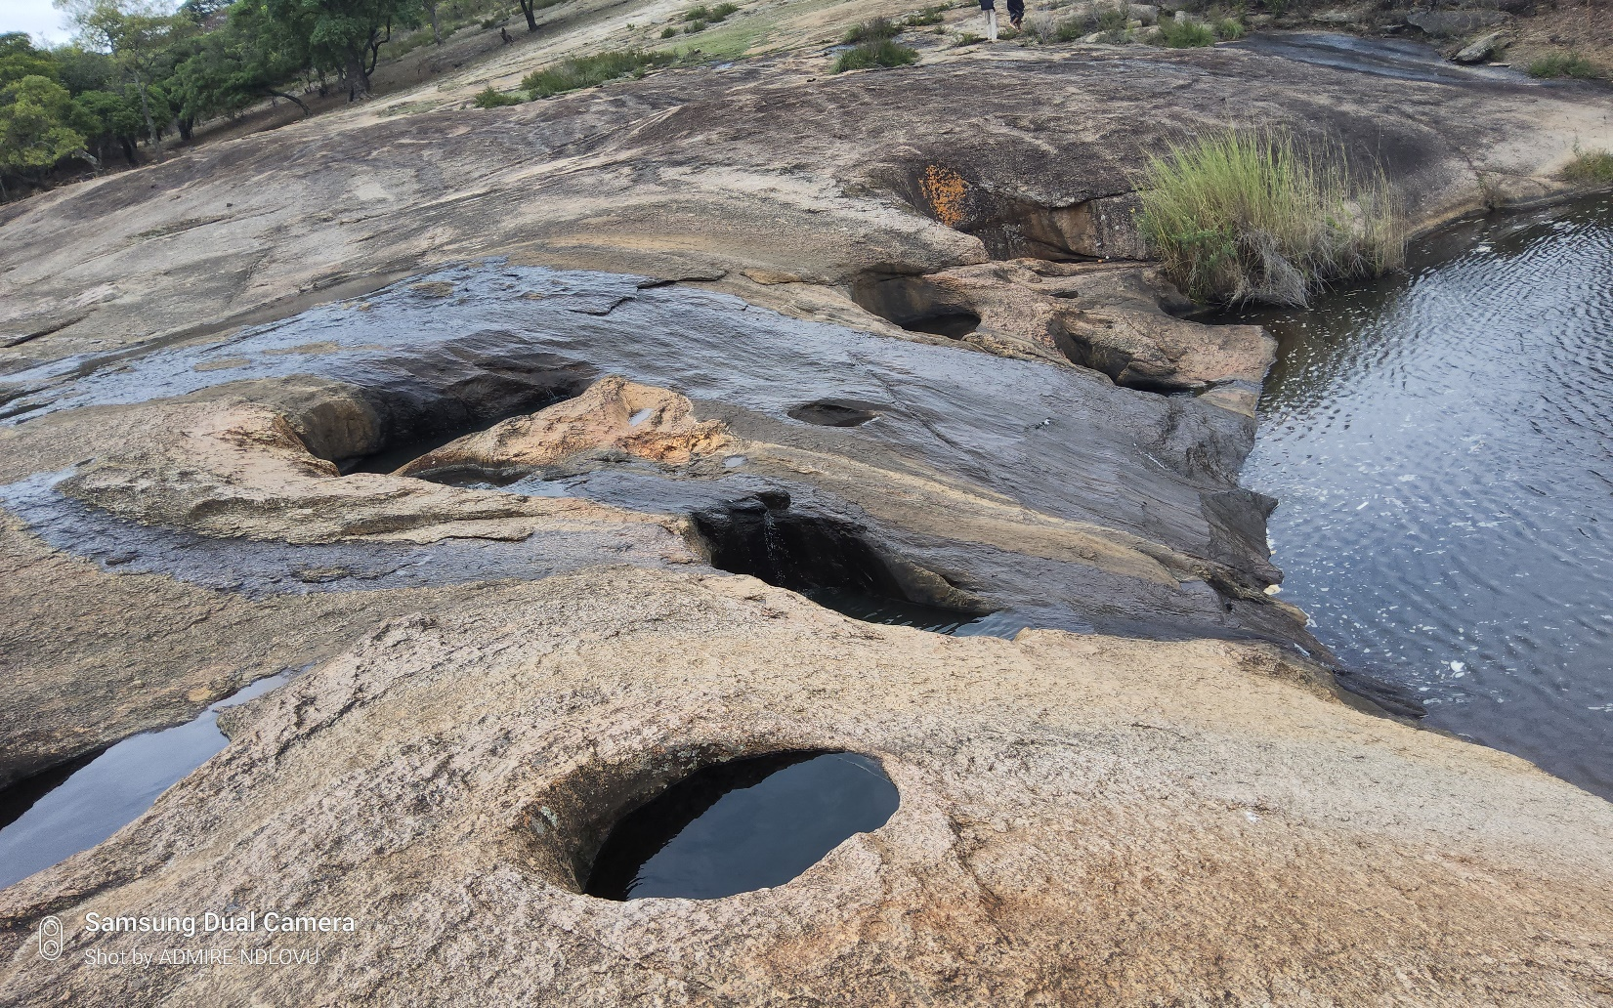

Orbicular Granite

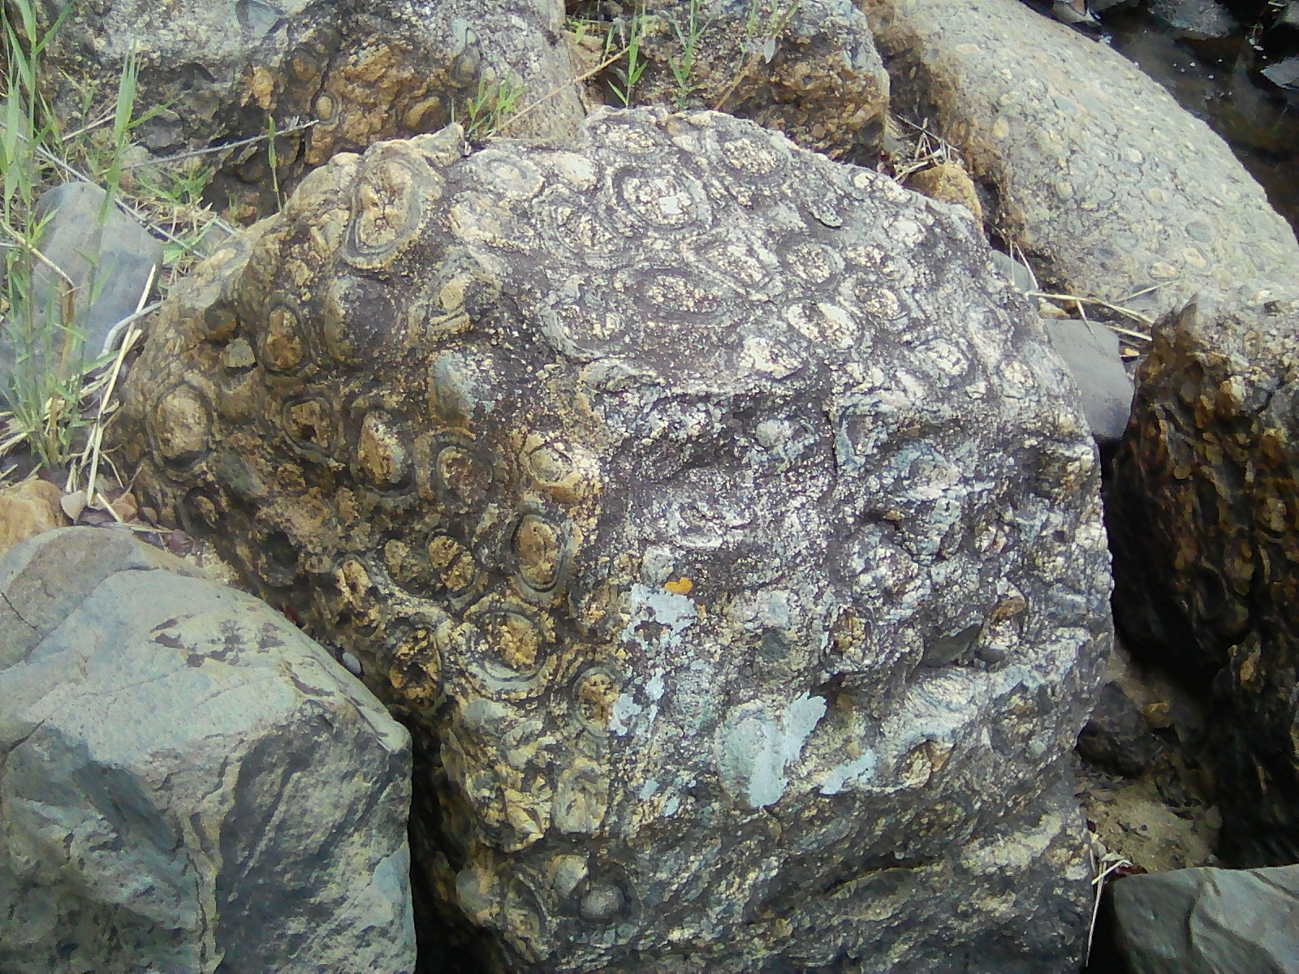

**2. Health:**

***There are 18 clinics in the district with wards 7,9,15,and 20 having no clinics in the wards.***

***Of the 18 clinics 5 are private, 4 are administered by the MoHCC and 9 are administered by the local authority.***

|  |  |  |  |
| --- | --- | --- | --- |
| ***Ward*** | ***Name health institution*** | ***No of wards covered*** | ***owner*** |
| ***1*** | ***Ntshamathe*** | ***1*** | ***Umzingwane RDC*** |
| ***2*** | ***Nhlangano*** | ***2*** | ***Umzingwane RDC*** |
| ***3*** | ***Sibomvu*** | ***3, part of4, 5 and 8*** | ***Umzingwane RDC*** |
| ***4*** | ***Mbizingwe*** | ***4*** | ***MoHCC*** |
| ***5*** | ***Mawabeni*** | ***5*** | ***Umzingwane RDC*** |
| ***6*** | ***Nswazi*** | ***6, 7*** | ***Umzingwane RDC*** |
| ***8*** | ***Shale*** | ***8*** | ***Umzingwane RDC*** |
| ***10*** | ***Mhlahlandlela*** | ***9,10*** | ***Umzingwane RDC*** |
| ***11*** | ***Dula*** | ***11*** | ***Umzingwane RDC*** |
| ***12*** | ***Kumbudzi*** | ***12,11*** | ***MoHCC*** |
| ***13*** | ***Irisvale*** | ***13*** | ***MoHCC*** |
| ***14*** | ***Mpisini*** | ***14*** | ***MoHCC*** |
| ***16*** | ***Habane*** | ***16*** | ***Umzingwane RDC*** |
| ***17*** | ***Mzingwane High School*** | ***17, 3*** | ***MoHCC*** |
| ***17*** | ***Esigodini District Hospital*** | ***1-20*** | ***MoHCC*** |
| ***18*** | ***Howminie*** | ***18,4*** | ***Howmine*** |
| ***19*** | ***Zimbili*** | ***19*** | ***Umzingwane RDC*** |
| ***19*** | ***Falcon*** | ***19*** | ***Falcon College*** |
| ***20*** | ***Mbalabala*** | ***20*** | ***ZNA*** |

There are still challenges on clinic coverages especially in wards as the average distances travelled to health facility exceeds a radius of 6km . An example is in wards where there are no clinics such as 7, 9 and in wards with large area coverages such as wards114, 19 and 20. Another challenge is on the staffing allocation set which makes it difficult to offer efficient services when on is in

**3. Education: Table 1 shows the number of schools and enrolment in 2017**

|  |  |  |  |
| --- | --- | --- | --- |
|  | **No of schools/institutions** | **No of satellite schools/annex** | **Low Cost Boarding facilities** |
| **Primary** | 38 | 7 all in resettlement wards |  |
| **Secondary** | 14 | 2 | Ward 6, Ward 10 functional and ward 2 and 14 complete structures which are yet to be operational |
| **Tertiary** | Esikhoveni Agric College  Esigodini Vocational Training Centre | 0 |  |

Seven schools in the district have been granted A level status.

Plan international is assisting in school fees payment and engaging in to fight teen pregnancies and early child marriages.

**Two low cost boarding facilities have been constructed with funding from Plan International at Sihlengeni High School and Bayethe Secondary Schools. These facilities are in line with Strategic Goal Number 4 on equal opportunities to education. In addition, there is a giant step in the fight against sexual abuse that sometimes occurs to girl children when travelling long distances through forests.**

**4. Water and sanitation:**

* District has 245 boreholes, 109 deep wells and 80 dams.Despite having dams as Ncema with huge masses of water, the major limiting factor to utilization of water by communities in Umzingwane is that the City Council of Bulawayo owns these dams; hence an estimated 80% of water is for Bulawayo and only 20% is for use by Umzingwane communities.
* ZINWA supplies water to part of ward 1,3,5 and the whole of ward 16
* There are piped water schemes in wards 2 – Ntabamhlophe and Ward 3- Esikhoveni that were established through Rural Wash Programme

**INFRASTRUCTURE**

**ROADS**

The district has a road network of 689.00km that are under the following road authorities:-

Umzingwane Rural District Council

RIDA – Rural Infrastructure Development Authority

Ministry of Transport

70,70 km of roads are tarred within wards 15,16.17,18 and 19

188.60Km are earth roads; 259.30km are Secondary – Gravel Roads while

170.40km are Tertiary Feeder – Gravel Roads.

National Road – Victoria Falls-Bulawayo-Beitbridge Road that links Zimbabwe with South Africa and Victoria Falls- Bulawayo-Masvingo and Mutare roads that links tourist destinations also passes through the district.

The district also has the Bulawayo-Beitbridge railway line passing through the district. From Bulawayo through the district, the railway line passes through wards 1,18,19,17,16,3,5 and 20.

1.